**JAVA SWING BASED –Suggesting a policy for delay of payments- SQL CONNECTIVITY USING JDBC**

*Report*

*Submitted in partial fulfillment of the Requirements for the award of the Degree of*

**BACHELOR OF ENGINEERING IN**

**INFORMATION TECHNOLOGY**

**By**

### T.shiva charan <1602-20-737-038>

**Under the guidance of Ms B. Leelavathy**

|  |
| --- |
|  |
|  | C:\Users\SHIVAC~1\AppData\Local\Temp\ksohtml21200\wps1.png |

### Department of Information Technology Vasavi College of Engineering (Autonomous) (Affiliated to Osmania University) Ibrahimbagh, Hyderabad-31

**2020-2021**

BONAFIDE CERTIFICATE

This is to certify that this project report titled

***‘*Suggesting a policy for delay of payments*’***

is a project work of **T shiva charan** bearing roll no. 1602-20-737-038 who carried out this project under my supervision in the IV semester for the academic year 2021- 2022

Signature Signature

External Examiner Internal Examiner

# **ABSTRACT**

In this project, we have to create a database where it has the details of the punishments that are implemented on the people are delaying the payments on traffic challans.

To implement this database records and to display all the data on the screen we need to build this database with details of vehicle ,person ,policy and number of challans that are imposed on the person .To build this database, we are using Run SQL for the backend and java for the frontend part.

Suggesting a policy for delay payments

**ABSTRACT: this project is useful in suggesting a policy for delay of payments in traffic challans**

**REQUIREMENT ANALYSIS**

List of Tables**:**

* challan
* Person
* Vehicle
* policy

**List of Attributes with their Domain Types:**

**Challan:**

|  |  |
| --- | --- |
| o Status | Varchar2(20) |
| Issue_date | date |
| Last_date | Date() |
| Paid_date        Vehicle: | Date() |
| o pID | NUMBER(5) |
| o liscence_num | NUMBER |
| o vehicle_num | VARCHAR2(100) |
| o vehicle_name | VARCHAR2(100) |

person

* pid NUMBER
* Pname VARCHAR2(20)
* age NUMBER(10)

**Policy:**

* cID NUMBER(5)
* No_of_challans NUMBER
* punishment varchar2(20)

**DESIGN**

ER DIAGRAM

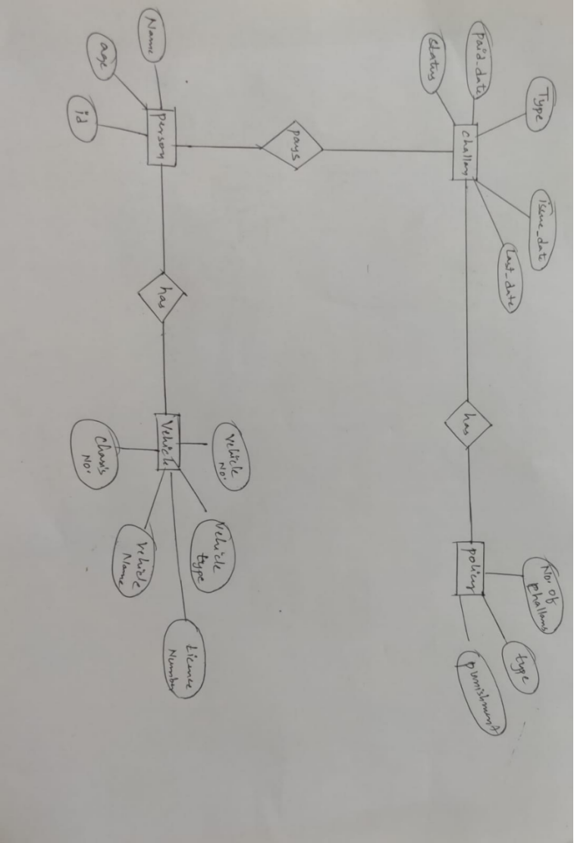

### JAVA-SQL Connectivity using JDBC:

**Java Database Connectivity (JDBC)** is an application programming interface (API) for the programming language Java, which defines how a client may access a database. It is a Java-based data access technology used for Java database connectivity. It is part of the Java Standard Edition platform, from Oracle Corporation. It provides methods to query and update data in a database and is oriented towards relational databases.

The connection to the database can be performed using Java programming (JDBC API) as:

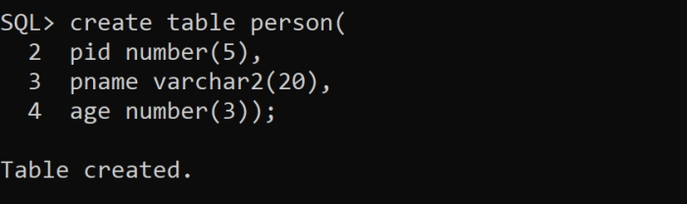

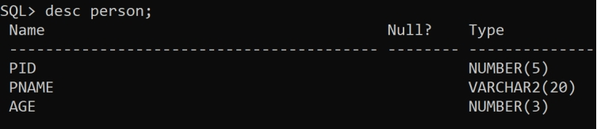

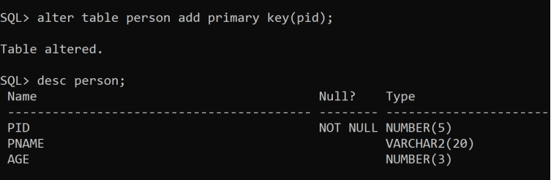

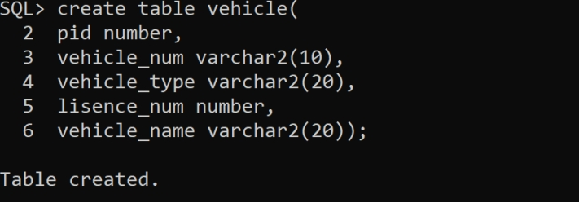

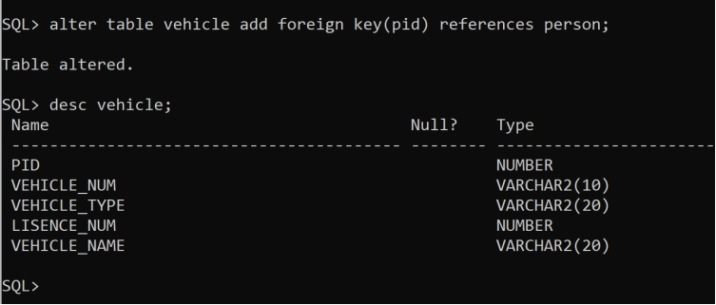

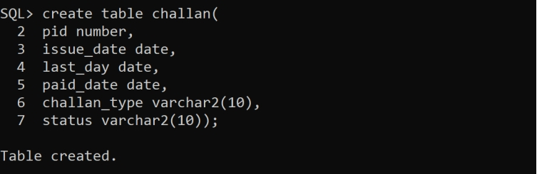

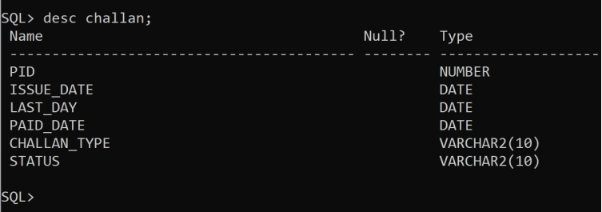

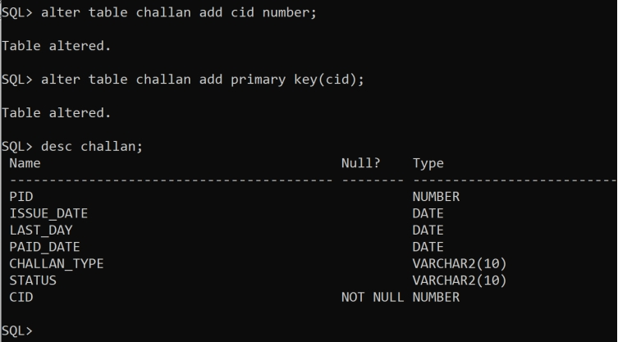

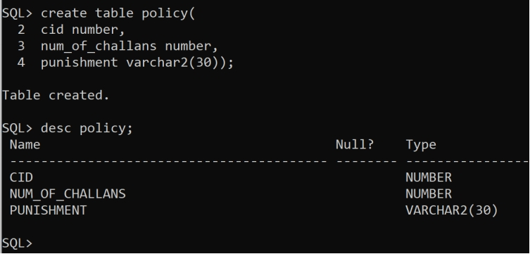

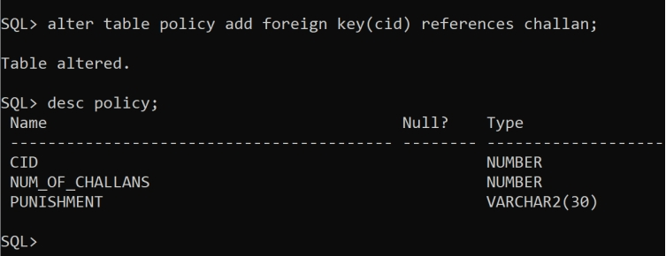

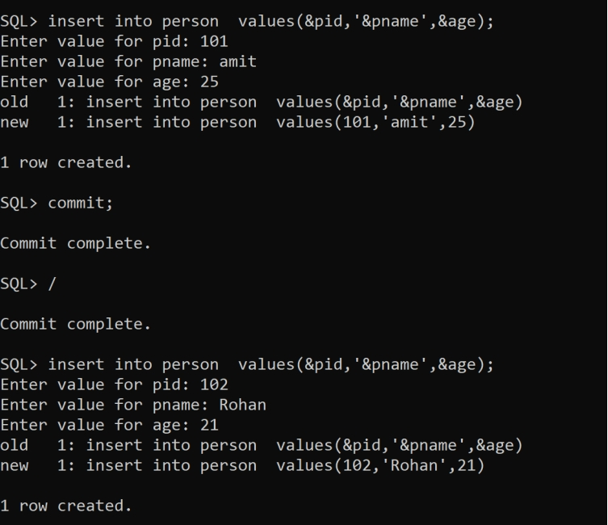

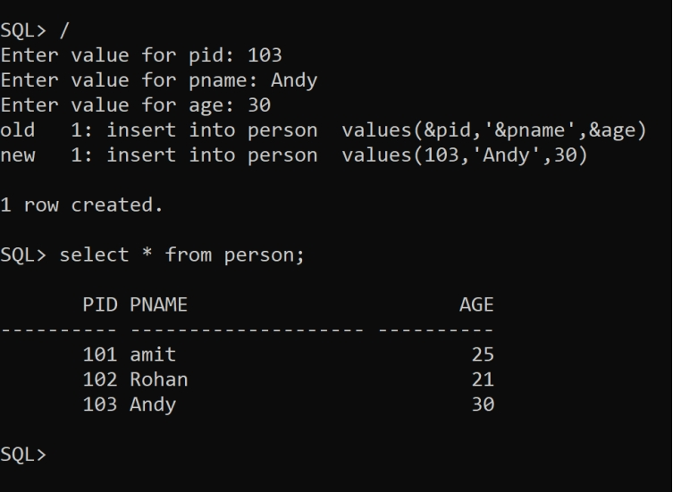

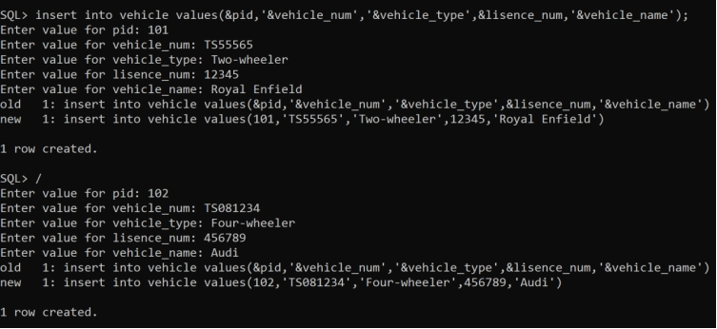

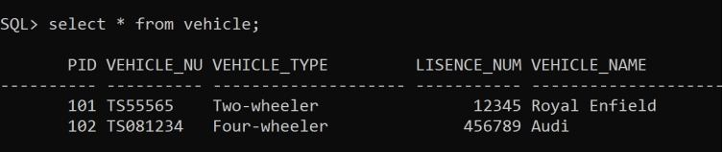

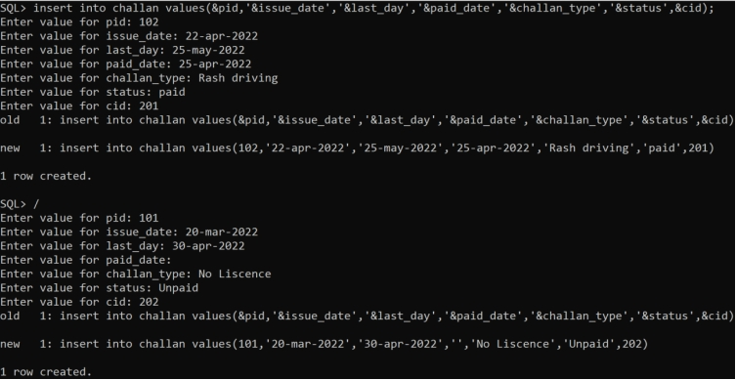

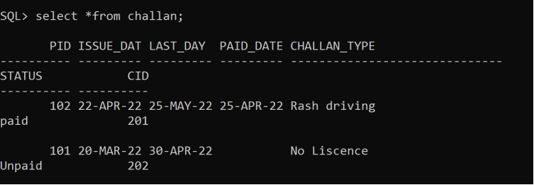

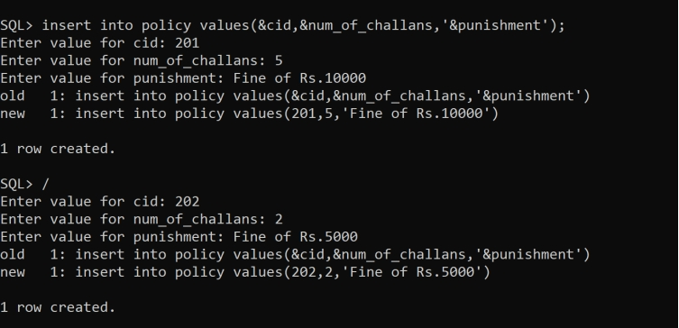

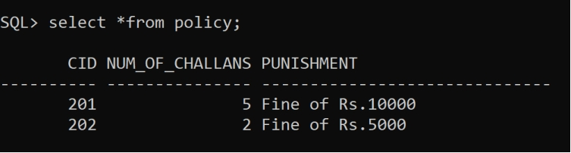

Code;

**import** java.awt.*;

**import** java.awt.event.*;

**import** javax.swing.*;

**import** java.sql.*;

**class** MainUI **extends** JFrame **implements** ActionListener

{

challanUI ob1;

PersonUI ob2;

VehicleUI ob3;

PolicyUI ob4;

JButton submit,modify,delete,m1,m2,m3,m4;

JPanel p1,p2,p3,p4,pb;

JMenuBar mb;

**public** MainUI()

{

setSize(600,550);

setLayout(**null**);

setVisible(**true**);

setTitle("policy for delay payments");

ob1 = **new** challanUI() ;

ob2 = **new** PersonUI ();

ob3= **new** VehicleUI ();

ob4= **new** PolicyUI ();

createPanels();

createMenu();

createButtons();

addComponents();

setDefaultCloseOperation(JFrame.EXIT_ON_CLOSE);

}

**void** createPanels()

{

p1 = ob1.p;

p2 = ob2.p;

p3 = ob3.p;

p4 = ob4.p;

pb = **new** JPanel(**new** FlowLayout(FlowLayout.CENTER,50,0));

pb.setBounds(0,400,600,150);

}

**void** createMenu()

{

mb = **new** JMenuBar();

m1 = **new** JButton("challan");

m1.setFocusable(**false**);

m2 = **new** JButton("Person");

m2.setFocusable(**false**);

m3 = **new** JButton("Vehicle");

m3.setFocusable(**false**);

m4 = **new** JButton("policy");

m4.setFocusable(**false**);

m1.addActionListener(**this**);

m2.addActionListener(**this**);

m3.addActionListener(**this**);

m4.addActionListener(**this**);

mb.add(m1);

mb.add(m2);

mb.add(m3);

mb.add(m4);

}

**public** **void** actionPerformed(ActionEvent ae)

{

remove(p1);

remove(p2);

remove(p3);

remove(p4);

**if**(e.getSource()==m1)

add(p1);

**else** **if**(e.getSource()==m2)

add(p2);

**else** **if**(e.getSource()==m3)

add(p3);

**else**

add(p4);

}

**void** createButtons()

{

submit = **new** JButton("Submit");

submit.addActionListener(**new** ActionListener()

{

**public** **void** actionPerformed(ActionEvent ae)

{

**try**{

Class.forName("oracle.jdbc.OracleDriver");

Connection con=DriverManager.getConnection("jdbc:oracle:thin:@localhost:1521:xe","shiva","vasavi");

Statement stmt=con.createStatement();

**int** no1 = Integer.parseInt(ob2.t3.getText());

**int** no2 = Integer.parseInt(ob2.t2.getText());

**int** s = stmt.executeUpdate("insert into Person values ("+no1+",'"+ob2.t1.getText()+"',"+no2+")");

con.close();

}

**catch**(Exception e){

System.out.println(e);

}

JOptionPane.showMessageDialog(**new** JFrame(),"Successfully Inserted!","NOTICE",JOptionPane.INFORMATION_MESSAGE);

}

});

modify = **new** JButton("Modify");

modify.addActionListener(**new** ActionListener()

{

**public** **void** actionPerformed(ActionEvent ae)

{

JOptionPane.showMessageDialog(**new** JFrame(),"Successfully Modified!","NOTICE",JOptionPane.INFORMATION_MESSAGE);

}

});

delete = **new** JButton("Delete");

delete.addActionListener(**new** ActionListener()

{

**public** **void** actionPerformed(ActionEvent ae)

{

JOptionPane.showMessageDialog(**new** JFrame(),"Successfully Deleted!","NOTICE",JOptionPane.INFORMATION_MESSAGE);

}

});

pb.add(submit);

pb.add(modify);

pb.add(delete);

}

**void** addComponents()

{

add(p1);

add(pb);

setJMenuBar(mb);

}

**public** **static** **void** main(String args[])

{

**new** MainUI();

}

}

**import** javax.swing.*;

**public** **class** PersonUI

{

JTextField t1,t2,t3;

JLabel l1,l2,l3;

JPanel p;

**public** PersonUI()

{

createComponents();

addComponents();

}

**void** createComponents()

{

t1 = **new** JTextField();

t1.setBounds(250,20,200,30);

t2 = **new** JTextField();

t2.setBounds(250,80,200,30);

t3 = **new** JTextField();

t3.setBounds(250,140,200,30);

l1 = **new** JLabel("Name : ");

l1.setBounds(100,20,100,30);

l2 = **new** JLabel("age: ");

l2.setBounds(100,80,100,30);

l3 = **new** JLabel("id: ");

l3.setBounds(100,140,100,30);

p = **new** JPanel(**null**);

p.setBounds(0,0,600,400);

}

**void** addComponents()

{

p.add(l1);

p.add(t1);

p.add(l2);

p.add(t2);

p.add(l3);

p.add(t3);

//add(p1);

}

}

**import** javax.swing.*;

**public** **class** PolicyUI

{

JTextField t1,t2,t3;

JLabel l1,l2,l3;

JPanel p;

**public** PolicyUI()

{

createComponents();

addComponents();

}

**void** createComponents()

{

t1 = **new** JTextField();

t1.setBounds(250,20,200,30);

t2 = **new** JTextField();

t2.setBounds(250,80,200,30);

t3 = **new** JTextField();

t3.setBounds(250,140,200,30);

l1 = **new** JLabel("No. of challans : ");

l1.setBounds(100,20,100,30);

l2 = **new** JLabel("type: ");

l2.setBounds(100,80,100,30);

l3 = **new** JLabel("punishment: ");

l3.setBounds(100,140,100,30);

p = **new** JPanel(**null**);

p.setBounds(0,0,600,400);

}

**void** addComponents()

{

p.add(l1);

p.add(t1);

p.add(l2);

p.add(t2);

p.add(l3);

p.add(t3);

//add(p1);

}

}

**import** javax.swing.*;

**class** challanUI

{

JTextField t1,t2,t3,t4,t5;

JLabel l1,l2,l3,l4,l5;

JPanel p;

**public** challanUI()

{

createComponents();

addComponents();

}

**void** createComponents()

{

t1 = **new** JTextField();

t1.setBounds(250,20,200,30);

t2 = **new** JTextField();

t2.setBounds(250,80,200,30);

t3 = **new** JTextField();

t3.setBounds(250,140,200,30);

t4 = **new** JTextField();

t4.setBounds(250,200,200,30);

t5 = **new** JTextField();

t5.setBounds(250,300,200,30);

l1 = **new** JLabel("Type : ");

l1.setBounds(100,20,100,30);

l2 = **new** JLabel("issue_date: ");

l2.setBounds(100,80,100,30);

l3 = **new** JLabel("paid_date : ");

l3.setBounds(100,140,100,30);

l4 = **new** JLabel("last_date : ");

l4.setBounds(100,200,100,30);

l5 = **new** JLabel("status : ");

l5.setBounds(100,300,100,30);

p = **new** JPanel(**null**);

p.setBounds(0,0,600,400);

}

**void** addComponents()

{

p.add(l1);

p.add(t1);

p.add(l2);

p.add(t2);

p.add(l3);

p.add(t3);

p.add(l4);

p.add(t4);

p.add(l5);

p.add(t5);

//add(p1);

}

}

**import** javax.swing.*;

**class** VehicleUI

{

JTextField t1,t2,t3,t4,t5;

JLabel l1,l2,l3,l4,l5;

JPanel p;

**public** VehicleUI()

{

createComponents();

addComponents();

}

**void** createComponents()

{

t1 = **new** JTextField();

t1.setBounds(250,20,200,30);

t2 = **new** JTextField();

t2.setBounds(250,80,200,30);

t3 = **new** JTextField();

t3.setBounds(250,140,200,30);

t4 = **new** JTextField();

t4.setBounds(250,200,200,30);

t5 = **new** JTextField();

t5.setBounds(250,300,200,30);

l1 = **new** JLabel("Vehicle no. : ");

l1.setBounds(100,20,100,30);

l2 = **new** JLabel("vehicle type: ");

l2.setBounds(100,80,100,30);

l3 = **new** JLabel("Licence no. : ");

l3.setBounds(100,140,100,30);

l4 = **new** JLabel("Vehicle Name : ");

l4.setBounds(100,200,100,30);

l5 = **new** JLabel("chasis no. : ");

l5.setBounds(100,300,100,30);

p = **new** JPanel(**null**);

p.setBounds(0,0,600,400);

}

**void** addComponents()

{

p.add(l1);

p.add(t1);

p.add(l2);

p.add(t2);

p.add(l3);

p.add(t3);

p.add(l4);

p.add(t4);

p.add(l5);

p.add(t5);

//add(p1);

}

}

**import** java.sql.*;

**public** **class** Connect{

**public** **static** **void** main(String[] args){

**try**{

Class.forName("oracle.jdbc.OracleDriver");

Connection con=DriverManager.getConnection("jdbc:oracle:thin:@218.248.0.7:1521:rdbms"," it20737038","vasavi'");

Statement stmt=con.createStatement();

ResultSet rs=stmt.executeQuery("select * from EXAMPLE");

**while**(rs.next())

System.out.println(rs.getString(1)+" "+rs.getString(2));

con.close();

}

**catch**(Exception e){

System.out.println(e);

}

}

}

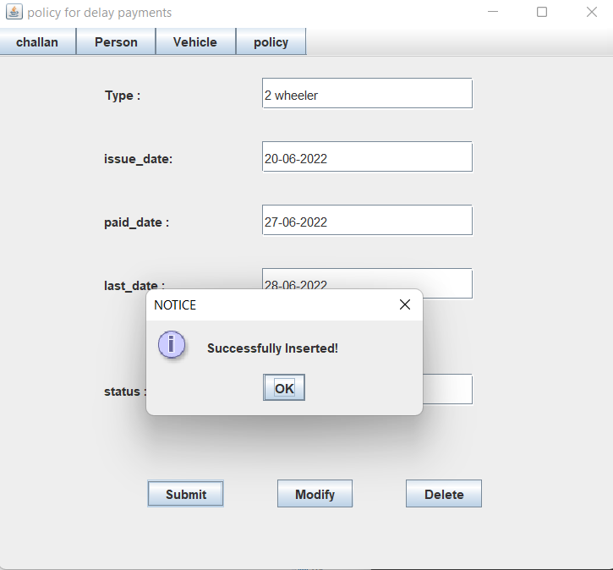

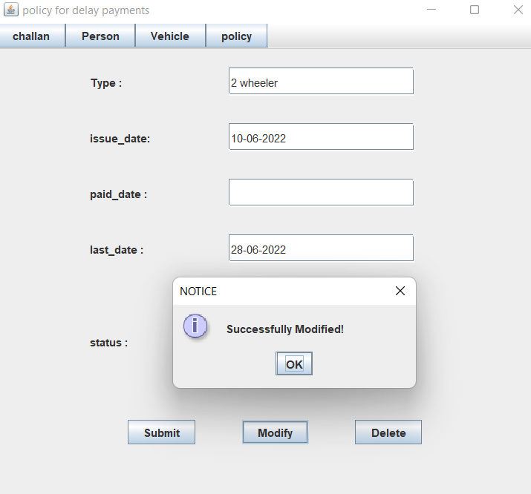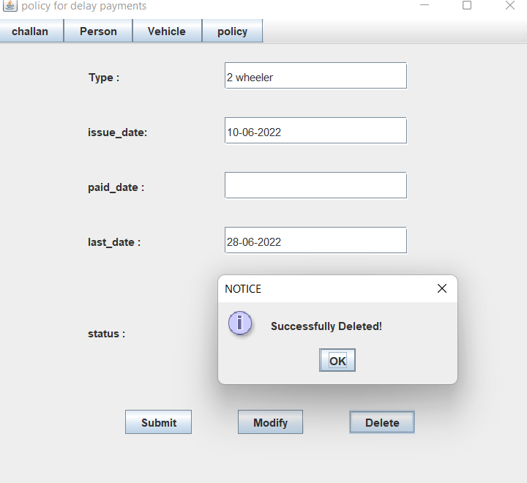

**RESULTS**

I have successfully completed the mini-project ***“suggesting a policy for delay payments”***

## DISCUSSION AND FUTURE WORK

This project contains the basic information about penalities which should be imposed on public for delay of payments

. Future scope would be to make the UI more appealing by using graphics. One more feature would be to add login page to

this interface.

## REFERENCES

* <https://docs.oracle.com/javase/7/docs/api/>
* <https://www.javatpoint.com/java-swing>
* <https://stackoverflow.com/>